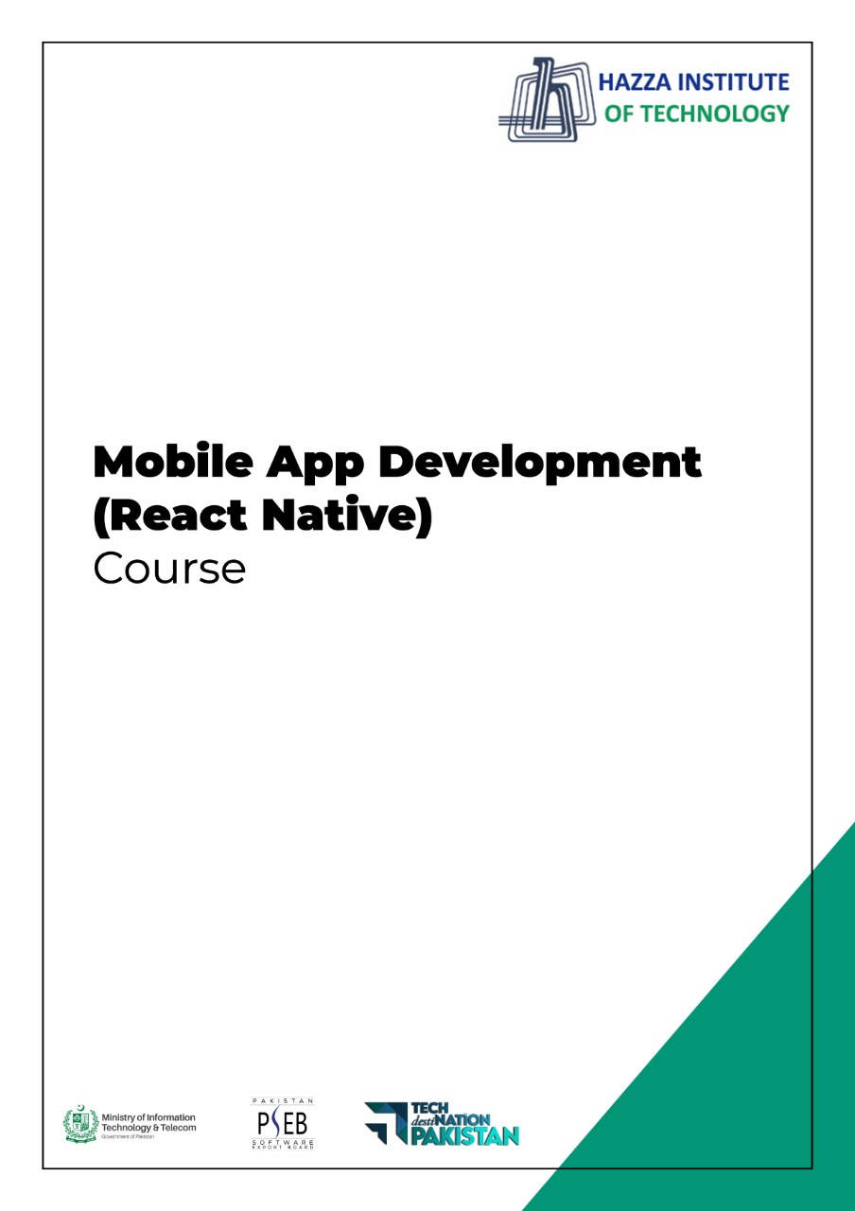

**(Flutter: Dart)**

Lab 2 (Session 1)

**Total Time:**

**3 hours (sessions-1)**

**Pre-Lab Activities:**

* + Familiar with dartpad for dart Editor

**Learning Outcomes:**

* + Demonstrate the basic knowledge of Dart.

**Student Activities:**

* + Open Dartpad, and do some exercise for dart

**Lab Tasks 1:**

Create a program that asks the user to enter their name and their age. Print out a message that tells how many years they have to be 100 years old.

**Lab Tasks 2:**

Ask the user for a number. Depending on whether the number is even or odd, print out an appropriate message to the user.

**Lab Tasks 3:**

Take a list, say for example this one:

a = [1, 1, 2, 3, 5, 8, 13, 21, 34, 55, 89]

and write a program that prints out all the elements of the list that are less than 5.

**Lab Tasks 4:**

Create a program that asks the user for a number and then prints out a list of all the divisors of that number.

If you don’t know what a divisor is, it is a number that divides evenly into another number. For example, 13 is a divisor of 26 because 26 / 13 has no remainder.

**Lab Tasks 5:**

Take two lists, for example:

a = [1, 1, 2, 3, 5, 8, 13, 21, 34, 55, 89]

b = [1, 2, 3, 4, 5, 6, 7, 8, 9, 10, 11, 12, 13]

and write a program that returns a list that contains only the elements that are common between them (without duplicates). Make sure your program works on two lists of different sizes.

**Lab Tasks 6:**

Ask the user for a string and print out whether this string is a palindrome or not.

A palindrome is a string that reads the same forwards and backwards.

**Lab Tasks 7:**

Let’s say you are given a list saved in a variable:

a = [1, 4, 9, 16, 25, 36, 49, 64, 81, 100].

Write a Dart code that takes this list and makes a new list that has only the even elements of this list in it.

**Lab Solutions:**

**LAB 2.1 :**

|  |
| --- |
| import 'dart:io';  void main() {  stdout.write("What's your name? ");  String name = stdin.readLineSync();  print("Hi, $name! What is your age?");  int age = int.parse(stdin.readLineSync());  int yearsToHunderd = 100 - age;  print("$name, You have $yearsToHunderd years to be 100");  } |

**LAB 2.2 :**

|  |
| --- |
| import 'dart:io';  void main() {  stdout.write("Hi, please choose a number: ");  int number = int.parse(stdin.readLineSync());    if (number % 2 == 0) {  print("Chosen number is even");  }  else {  print("Chosen number is odd");  }  } |

**LAB 2.3 :**

|  |
| --- |
| void main() {  List<int> a = [1, 1, 2, 3, 5, 8, 13, 21, 34, 55, 89];  for (var i in a) {  if (i < 5) {  print(i);  }  }    // One liner  print([for (var i in a) if (i < 5) i]);  } |

**LAB 2.4 :**

|  |
| --- |
| import 'dart:io';  void main() {  stdout.write("Please choose a number: ");  int number = int.parse(stdin.readLineSync());  for (var i = 1; i <= number; i++) {  if (number % i == 0) {  print(i);  }  }  } |

**LAB 2.5 :**

|  |
| --- |
| void main() {  List<int> a = [1, 1, 2, 3, 5, 8, 13, 21, 34, 55, 89];  List<int> b = [1, 2, 3, 4, 5, 6, 7, 8, 9, 10, 11, 12, 13, 89];  Set<int> c = {};  for (var i in a) {  for (var j in b) {  if (i == j) {  c.add(i);  }  }  }  print(c.toList());  // One liner using set intersections  print(Set.from(a).intersection(Set.from(b)).toList());  } |

**LAB 2.6 :**

|  |
| --- |
| import 'dart:io';  void main() {    stdout.write("Please give a word: ");  String input = stdin.readLineSync().toLowerCase();  String revInput = input.split('').reversed.join('');    // Ternary operator  input == revInput  ? print("The word is palindrome")  : print("The word is not a palindrome");  } |

**LAB 2.7 :**

|  |
| --- |
| void main() {  List<int> a = [1, 4, 9, 16, 25, 36, 49, 64, 81, 100];  int i = 0;  List<int> l = [];  for (var e in a) {  if (++i % 2 == 0) {  l.add(e);  }  }  print(l);    // One liner  print([for (var e in a) if (++i % 2 == 0) e]);  } |